HERPETOFAUNA OF THE SEFTON COAST

Date: Sunday 3rd May 2015

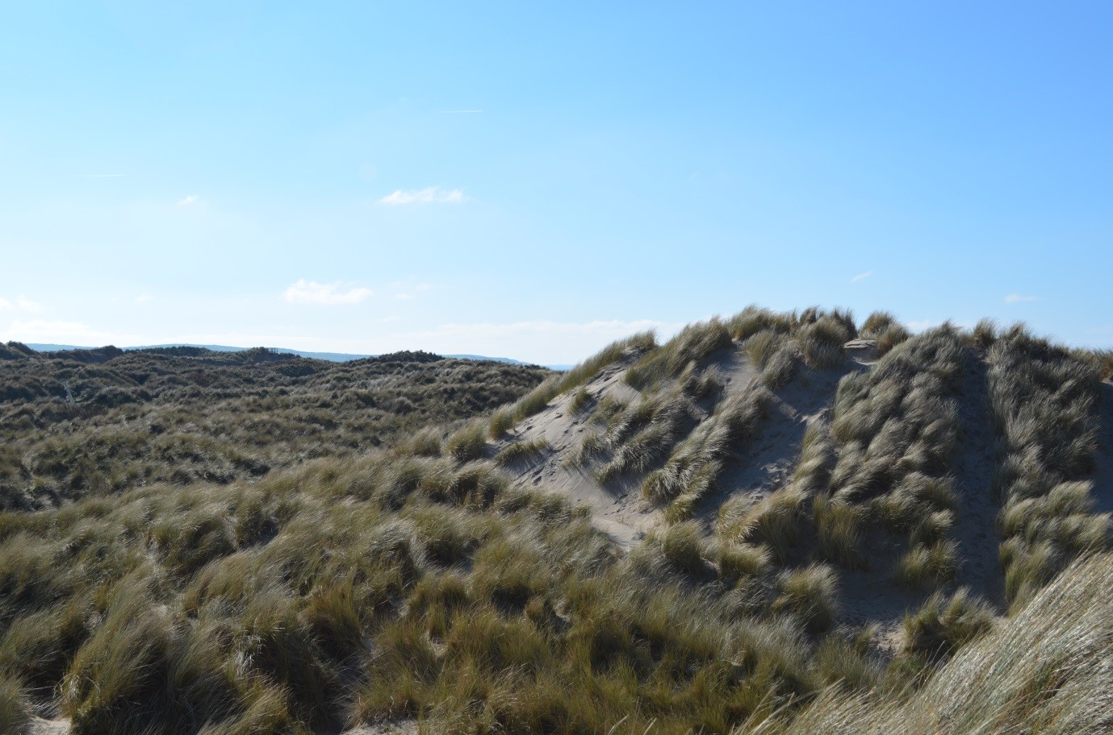 | 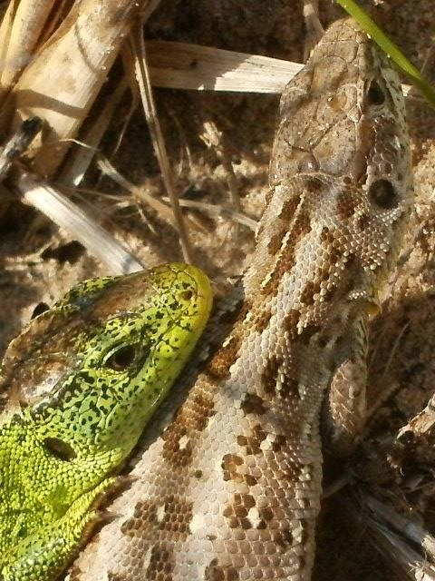 | 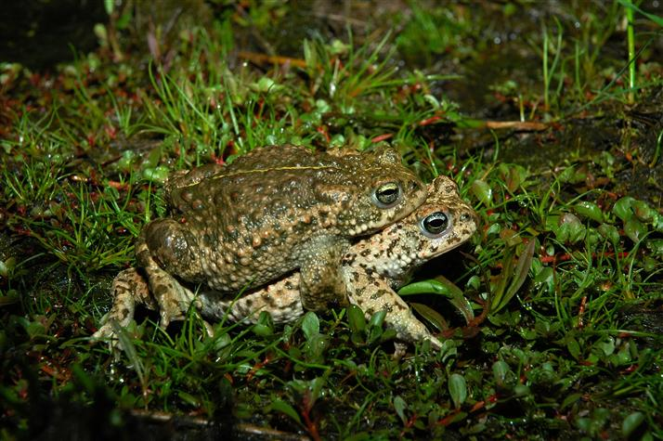

All photographs courtesy of NW Merseyside Amphibian & Reptile Group http://groups.arguk.org and Amphibian and Reptile Conservation http://www.arc-trust.org

Please note that due to limited numbers this event is open to BHS members only

Cost: £15 registration fee

Provisional itinerary

- Morning - Meet at 9am at the Ainsdale dunes, to see sand lizards and other herpetofauna. We will visit a couple of sites, which should will also provide the opportunity to see the work recently completed to reinstate the dune habitat by NW Merseyside Amphibian & Reptile Group, with funding provided by the BHS Conservation Fund.

- Afternoon – Meet at 2pm near Ainsdale village, to look at fixed dune habitats where more habitat management work has been undertaken.

- Evening – meet at 7.30 pm to see Natterjack Toads breeding by torchlight.

Field visits will be led by Mike Brown (NWMARG) and Jan Clemons (BHS). Maps & postcodes will be sent to all attendees prior to the field visit.

HERPETOFAUNA OF THE SEFTON COAST
BOOKING FORM

I wish to book……….place(s) on the 2015 Field visit to the Sefton Coast @ £15/person

I enclose a cheque for £…………. made payable to ‘The British Herpetological Society’.

Signed ……………………………………………… Date ………………………….

Please return this form and full payment to: Jan Clemons, 8, Carthusian Road, Coventry CV3 6HA by 17th April 2015 at the latest.
For further information please ring 07720 814414 or email clemonsj@btinternet.com

Advice for members
- Participants must take out their own personal & belongings insurance. The Society cannot accept any liability with regards to personal injury or loss or damage to belongings.
- Reptile sightings cannot be guaranteed, especially in the event of bad weather. Alternatives will be arranged where possible but please plan to bring waterproof boots and clothing together with a suitable torch for pond surveying.

Name………………………………. Daytime Tel. ………………………….. Mobile …………………………

Address …………………………………………………………………………

Postcode ……………………

Email……………………………………………………..

BHS membership number ………………..

